Software Requirements Specification

for

Kinderfind

**Version 3.0 approved**

**Prepared by Siek Ming Jun**

**6 November 2019**

**Revision History**

|  |  |  |  |
| --- | --- | --- | --- |
| **Name** | **Date** | **Reason For Changes** | **Version** |
| Joshua Ang | 06/11/19 | Creation of SRS | 1 |
| Siek Ming Jun | 06/11/19 | Additional changes made | 2 |
| Siek Ming Jun | 09/11/19 | Additional changes made | 3 |

# 

**Table of Contents**

1. Introduction 5

1.1 Purpose 5

1.2 Intended Audience and Reading Suggestions 5

1.3 Product Scope 5

1.4 References 6

2. Overall Description 6

2.1 Product Perspective 6

2.2 Product Functions 7

2.2.1 Use Case Diagram 7

2.2.2 Use Case Description 8

2.2.3 Class Diagram 23

2.2.4 Sequence Diagram 24

2.2.5 Dialog Map 30

2.2.6 Prototype UI 31

2.3 User Classes and Characteristics 32

2.4 Operating Environment 32

2.5 Design and Implementation Constraints 33

2.6 User Documentation 33

2.7 Assumptions and Dependencies 34

3. External Interface Requirements 34

3.1 User Interface 34

3.1.1 Sliding List View - Kindergarten Result Box 34

3.1.2 Action Bar 35

3.1.3 Menu Option 35

3.1.4 Buttons 35

3.1.5 Informative Toasts 36

3.1.6 Card View 36

3.1.7 Ratings Section 37

3.1.8 Reviews Section 37

3.1.9 Confirmation Dialogs 38

3.2 Adherence to Schneiderman’s 8 Golden Rules 38

3.2.1 Strive for Consistency 38

3.2.2 Cater to Universal Usability 38

3.2.3 Offer Informative Feedback 39

3.2.4 Design Dialog to Yield Closure 39

3.2.5 Permit Easy Reversal of Actions 39

3.2.6 Support Internal Locus of Control 39

3.2.7 Reduce Short-Term Memory Load 39

3.2.8 Prevent Error 39

3.3 Software Interfaces 40

3.4 Communications Interfaces 40

4. System Features 41

4.1 Login 41

4.2 Registration 41

4.3 Tutorial 42

4.4 View Map 42

4.5 Search Kindergarten 44

4.6 View Kindergarten Details 45

4.7 Submit Ratings and Reviews 46

4.8 Share Kindergarten 47

4.9 View Profile Page 47

5. Other Nonfunctional Requirements 48

5.1 Performance Requirements 48

5.2 Usability Requirements 48

5.3 Software Quality Attributes 48

5.4 Business Rules 49

5.4.1 User must register before using the app 49

5.4.2 User must be verified before posting ratings and review 49

6. Appendix A: Data Dictionary 49

# Introduction

## Purpose

The purpose of this Software Requirements Specification (SRS) document is to provide a full in-depth description of Kinderfind – a mobile platform which helps its users to explore kindergarten options in Singapore. This SRS describes a single subsystem which defines the system boundaries, interface and communications used with the external APIs and how it interacts with our application. It also includes the scope of the project, an overall description of the project, interface requirements, functional requirements, and non-functional requirements.

## Intended Audience and Reading Suggestions

This document is intended for developers, project managers, investors, testers and general users. Developers and project managers are recommended to read the entirety of this document. Investors, testers and general users are recommended to read the overall description and system features pertaining to the app in order to understand the features of this app.

## Product Scope

Kinderfind is a mobile app that will be designed, developed and implemented while leveraging on public APIs. The main goal of this project is to provide a platform for users to share and explore different kindergarten options located in Singapore. Our target audiences are parents, couples, newlyweds and preschool teachers. Depending on the target audience, they will have different reasons for using this app. For parents, Kinderfind would help them make the most informed and suitable choice of kindergarten to best nurture their children. For couples and newlyweds, the app could help them decide on which location in Singapore is suitable for them to plan their future. Our app aims to be a one-stop information app for kindergartens and allow users to speed up the process of searching. This will allow them to make informed decisions depending on their reason for using the app.

This will be accomplished by a user-friendly mobile application that consists of these main functions:

- View Kindergarten nearby sorted by distance.

- Search Kindergarten by name or tapping on the map.

- View general information of kindergarten and programs offered.

- Share kindergarten details with other users.

- View/submit ratings and reviews of each kindergarten written by other users.

## References

Integrating Android with Firebase:

<https://firebase.google.com/docs/android/setup/>

Using Ben Schneiderman’s 8 Golden Rules for User Interface design:

<https://faculty.washington.edu/jtenenbg/courses/360/f04/sessions/schneidermanGoldenRules.html>

Design Components in this application is based on this Material Design guidelines:

<https://material.io/design/>

# Overall Description

## Product Perspective

Kinderfind is a newly developed, self-contained product. It is meant to connect Google Map and the datasets provided publicly by data.gov.sg (data.gov). Google Map provides a visual representation of where the Kindergarten is located. However, it does not have all the kindergarten information that is available in Singapore. Thus, we integrate the datasets provided by data.gov which contains all kindergarten information with Google Map. With this, Kinderfind will be able to provide a visual representation of the kindergarten’s location while utilizing the dataset provided by data.gov to display general information to the user. Using these, we can implement additional features such as ratings and review to help users make informed decisions.

The major components of the overall system are defined in the **System Architecture** shown below. It is composed of Layout, Activities, Model & Entities and the Persistent Data Layer.

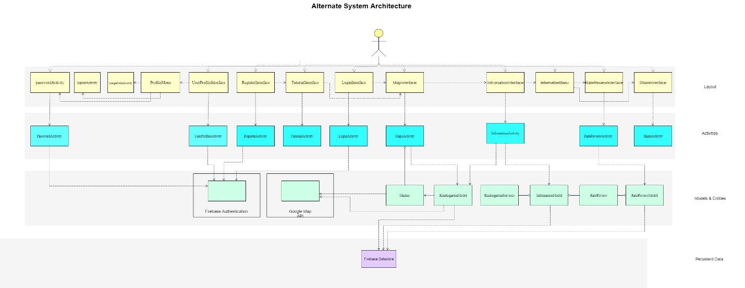

## Product Functions

### Use Case Diagram

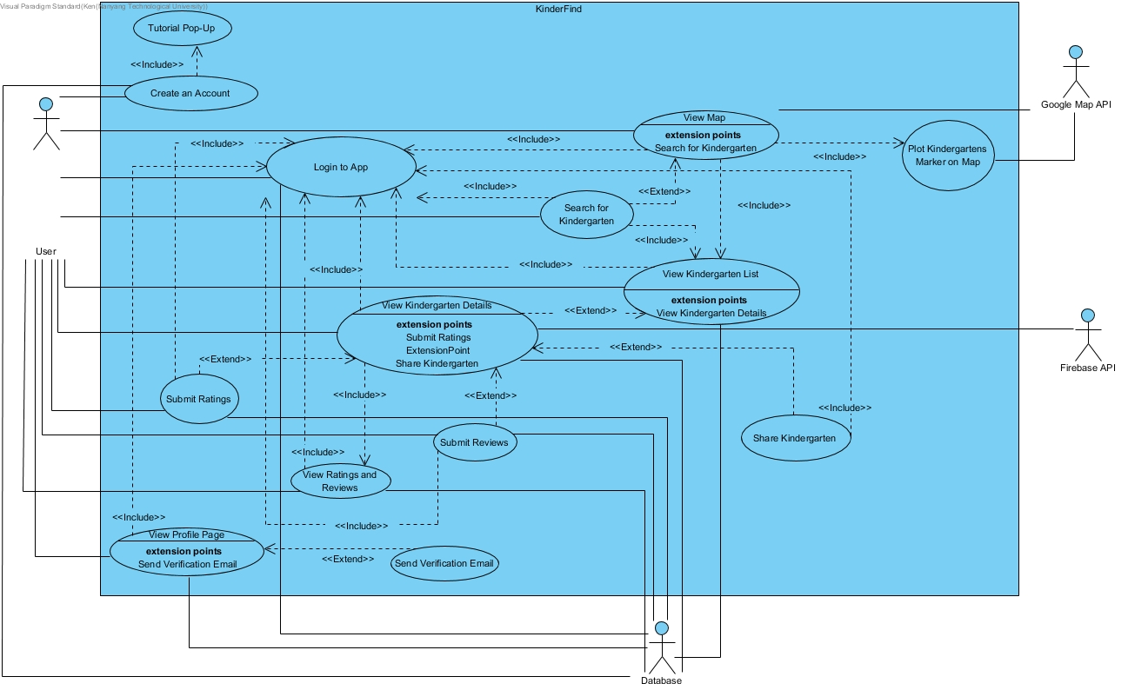

Major Functions of Kinderfind:

* Login to App
* Create an Account
* Tutorial Pop-Up
* View Map
* Search for kindergarten
* View Kindergarten Details
* View Ratings and Reviews
* Submit Ratings and Submit Reviews
* Share Kindergarten
* View Profile Page
* Plot Kindergartens Marker on Map
* Send Verification Email

### Use Case Description

**Login to App**

- Users are required to log in before being able to access the full functionalities of the app.

|  |  |  |  |
| --- | --- | --- | --- |
| Use Case ID: | UC001 | | |
| Use Case Name: | Login to App | | |
| Created By: | Vivian Siow | Last Updated By: | Vivian Siow |
| Date Created: | 1st September 2019 | Date Last Updated: | 2nd September 2019 |

|  |  |
| --- | --- |
| Actor: | User, Database |
| Description: | User logs into the app using their account |
| Preconditions: | 1. Invoked when user opens the KinderFinder app. 2. The user already has a registered, verified KinderFinder account. 3. KinderFinder database must be online 4. An active internet connection is required. 5. App must be downloaded. |
| Postconditions: | User will be logged into the application and access all functionalities of the application. |
| Priority: | Very High. Users must first login to the app in order to access the app and utilize the services it provides. |
| Frequency of Use: | High |
| Flow of Events: | 1. User launches the app 2. The app prompts the user to login with their account 3. User enters their username and password 4. The user’s credentials are validated by the app’s database 5. If the user’s credentials are valid, app logs user in and shows a toast message that they have successfully logged in. |
| Alternative Flows: | AF-S5 If the user’s credentials are invalid   1. App will display a toast message stating that the user did not login successfully 2. The app will return to step 2. |
| Exceptions: | - |
| Includes: | - |
| Special Requirements: | - |
| Assumptions: | - |
| Notes and Issues: | - |

**Create an Account**

- Users can create an account using verifiable information such as email address.

- A verification email will be sent to the user’s email.

- User’s verified status is set to false until they verified their email.

- Users are still able to access the app without verifying their email.

- Users are unable to post ratings and review until they verify their account.

|  |  |  |  |
| --- | --- | --- | --- |
| Use Case ID: | UC002 | | |
| Use Case Name: | Create Account | | |
| Created By: | Shearman Chua | Last Updated By: | Poh Ying Xuan |
| Date Created: | 31st August 2019 | Date Last Updated: | 19 October 2019 |

|  |  |
| --- | --- |
| Actor: | User, Database |
| Description: | User registers for an account with verifiable information such as email to be able to use and access the KinderFinder mobile application. |
| Preconditions: | 1. Invocation by the user when he clicks the “Create Account” button at UC001 Login to App page if the User does not have an account for the KinderFinder mobile application 2. An active internet connection is required 3. User must not already have a registered account 4. User must have an existing email address |
| Postconditions: | 1. User will have a verified KinderFinder account that is stored in the application’s database 2. The next time the user uses the application, he will not be required to create an account, he will just be required to log in to his existing account. |
| Priority: | High. User must be registered in order to fully utilize the app. |
| Frequency of Use: | Once by each unique user. |
| Flow of Events: | 1. User downloads and opens the mobile application for the first time. User will see the log in page from UC001 Login to App. The user clicks on “Create Account” button to create an account. 2. The user will be redirected to another page to register for an account. User will be required to enter verifiable information such as email address, username and profile picture. 3. An email verification will be sent to the user. If the operation was a success, a toast message will appear, indicating the success. 4. User is brought to UC005 Tutorial Pop-Up page for a mandatory tutorial on how to use the application. |
| Alternative Flows: | AF-S1: If user try to log in without a registered account   1. If the user tries to log in without a registered account, a toast message will be displayed stating that the user does not have a registered account. 2. The application returns to step 1.   AF-S2: If the required email is an incorrect format   1. A toast message will be displayed indicating the error. 2. The application returns to step 2. |
| Exceptions: | EX 1: If the application is unable to contact the database to register an account   1. An error message is displayed. 2. Application will return to step 2. |
| Includes: | UC005 Tutorial Pop-Up |
| Special Requirements: | - |
| Assumptions: | - |
| Notes and Issues: | - |

**Tutorial Pop-Up**

- When a user completes registering their account, they will be brought to the tutorial page.

- The tutorial page provides information on how to use the app.

- This allows the user to learn how the app functions and allows them to quickly adapt.

- Tutorial can be skip.

|  |  |  |  |
| --- | --- | --- | --- |
| Use Case ID: | UC005 | | |
| Use Case Name: | Tutorial Pop-Up | | |
| Created By: | Shearman Chua | Last Updated By: | Shearman Chua |
| Date Created: | 31st August 2019 | Date Last Updated: | 2nd September 2019 |

|  |  |
| --- | --- |
| Actor: | User |
| Description: | A step by step guide on how to use the application for first time users. |
| Preconditions: | 1. Invocation as an included use case UC002 Create Account. 2. User must have successfully created an account in UC002 Create Account. 3. An active internet connection is required. |
| Postconditions: | User will go through a step by step guide on how to use the application as well as an introduction to the main features of the application |
| Priority: | Medium. A step by step guide is necessary for first time users so that they will understand how to use the application and there will be lesser user dissatisfaction. |
| Frequency of Use: | Once for each unique user. |
| Flow of Events: | 1. After the user successfully register for an account from UC002, they will be redirected to the tutorial page. 2. The tutorial will consist of step by step guides for each main feature of the application. 3. User slides the carousel to see the next guide for another feature. 4. When user reaches the last tutorial guide, after pressing the “next” button, the user will be redirected to UC011. |
| Alternative Flows: | - |
| Exceptions: | - |
| Includes: | - |
| Special Requirements: | - |
| Assumptions: | - |
| Notes and Issues: | - |

**View Map**

- If the user allows Location Permission, in the map page, the map will be zoomed in on their current location. If not, the map will zoom in to the center of Singapore.

- Search bar will be displayed at the top of the app.

- Makers displaying where the kindergartens are will be displayed on the map.

- Kindergarten Result Box at the bottom of the app will display important kindergarten information.

- Kindergarten Result Box will sort kindergarten based on distance, with the closest kindergarten at the top of the list.

- Users can search for kindergarten using the search bar.

- Kindergarten Result Box will update according to what the user types.

- Tapping on a kindergarten in the Kindergarten Result Box will bring the user to the Information page.

|  |  |  |  |
| --- | --- | --- | --- |
| Use Case ID: | UC011 | | |
| Use Case Name: | View Map | | |
| Created By: | Hoo Bing Yuan | Last Updated By: | Hoo Bing Yuan |
| Date Created: | 1st September 2019 | Date Last Updated: | 2nd September 2019 |

|  |  |
| --- | --- |
| Actor: | User, Google Map API |
| Description: | Users will be shown a map of Singapore in which kindergartens are pinned on the map using Markers. |
| Preconditions: | 1. Invocation as an included use case of UC012 Plot Kindergartens Marker on Map when the user first loaded the map. 2. An active internet connection is required. |
| Postconditions: | User may be directed to UC010 View Kindergarten List or UC009 Search For Kindergarten based on their actions in UC011 View Map. |
| Priority: | High. |
| Frequency of Use: | Very High. Map would be used when the user requests to search for a particular kindergarten |
| Flow of Events: | 1. Upon first load, user would be prompted to allow permission to access device location. 2. Upon accepting, the map will be zoomed in to within a 5km radius of the user’s current location. 3. Application retrieves coordinates of kindergartens and UC012 Plot Kindergartens Marker on Map will be invoked. 4. Markers will appear on the map indicating the kindergartens. 5. User taps on a Markers and that particular Kindergarten would be shown on UC010 View Kindergarten List. |
| Alternative Flows: | AF-S1: If data cannot be obtained   1. The app displays a toast indicating that the data cannot be obtained. |
| Exceptions: | EX1: If user did not allow permission to access device   1. The application would zoom to an overview of Singapore 2. Application would be able to retrieve coordinates of kindergarten and UC012 Plot Kindergartens Marker on Map will be invoked. 3. However, the device location would not be known and UC011 View Map would not show the location of the user 4. UC010 View Kindergarten list would only show Kindergarten in an alphabetical order and not distance based. 5. Once user allow device location permission, application returns to step 2. |
| Includes: | UC001 Login to App  UC009 Search For Kindergarten  UC010 View Kindergarten List  UC012 Plot Kindergartens Marker on Map |
| Special Requirements: | - |
| Assumptions: | - |
| Notes and Issues: | - |

**Search for Kindergartens**

- Users can use the search bar to search for a kindergarten.

- Users can search using either kindergarten name, kindergarten address and kindergarten postal code. Users can search by using part of the name, address and postal code.

- Search results will be displayed in the Kindergarten Result Box shown at the bottom of the app.

|  |  |  |  |
| --- | --- | --- | --- |
| Use Case ID: | UC009 | | |
| Use Case Name: | Search for Kindergarten | | |
| Created By: | Shearman Chua | Last Updated By: | Shearman Chua |
| Date Created: | 31st September 2019 | Date Last Updated: | 2nd September 2019 |

|  |  |
| --- | --- |
| Actor: | User |
| Description: | User types in keywords in a textbox to search for relevant kindergartens. |
| Preconditions: | 1. User must be logged into the application with a registered KinderFinder account. 2. An active internet connection is required. |
| Postconditions: | User would be provided with a list of kindergartens that fit the relevant keywords being entered by the user. |
| Priority: | High. |
| Frequency of Use: | High. |
| Flow of Events: | 1. User taps on the search bar. 2. User types in either the name or address of a kindergarten that he/she wants to search for. 3. If results are found, the search results will be displayed accordingly from nearest to farthest kindergarten. |
| Alternative Flows: | AF-S1: User taps on the map in the background   1. User manually interacts with the map 2. User is directed to the included use case UC011 View Map.   AF-S3: If search is invalid   1. “No matching results were found” will be displayed on a pop-up toast message to the user. 2. The app returns to step 2. |
| Exceptions: | - |
| Includes: | UC001 Login to App  UC010 View Kindergarten List  UC011 View Map |
| Special Requirements: | - |
| Assumptions: | - |
| Notes and Issues: | - |

**View Kindergarten Details**

- When a user taps on a kindergarten in the Kindergarten Result Box, they will be brought to the Information page for that kindergarten.

- Information regarding this kindergarten is retrieved from data.gov by using the APIs for Kindergarten and List of Kindergarten Services dataset.

- Information for kindergarten and kindergarten services will be displayed in this page.

- Map showing where the kindergarten is located will be displayed.

- Average rating will be displayed.

- All reviews given for this kindergarten will be displayed sorted by latest review.

|  |  |  |  |
| --- | --- | --- | --- |
| Use Case ID: | UC006 | | |
| Use Case Name: | View Kindergarten Details | | |
| Created By: | Vivian Siow | Last Updated By: | Vivian Siow |
| Date Created: | 1st September 2019 | Date Last Updated: | 1st September 2019 |

|  |  |
| --- | --- |
| Actor: | User, Government Data API |
| Description: | User selects a kindergarten and its directed to this page where more information of the selected kindergarten is shown. |
| Preconditions: | 1. A kindergarten must be selected 2. An active internet connection is required 3. Invocation as an extension from UC010 View Kindergarten List |
| Postconditions: | Users will see more information of the selected kindergarten. |
| Priority: | Very high. It shows important information that allows users to make a final informed decision whether to enroll their child to a particular kindergarten. Without this feature, the app will lose its main purpose. |
| Frequency of Use: | Very high.   1. Every time a user wants to share this page, user would have to do it from this page. 2. Every time a user wants to leave a rating or review, user would have to do so from this page. 3. Any actions that is linked to a particular Kindergarten centre would have to be done through this page as this action outlines the selection of a Kindergarten centre. |
| Flow of Events: | 1. The app shows a page with detailed description of the kindergarten from the Gov Data API 2. If the user taps on the menu icon, he/she can select to use the extending use case UC007 Share or UC008 Rate/Review. |
| Alternative Flows: | AF-S1: If data cannot be obtained   1. The app displays a toast indicating that the data cannot be obtained. 2. Application returns to step 1.   AF-S1: Change their choice of selected kindergarten   1. User can tap the back button to return to UC010 View Kindergarten List to reselect another kindergarten of their choice. |
| Exceptions: | - |
| Includes: | UC001 Login to App  UC007 View Ratings and Reviews |
| Special Requirements: | - |
| Assumptions: | The API has sufficient information for every kindergarten listed in its database. |
| Notes and Issues: | - |

**View Ratings and Reviews**

- Ratings and reviews will be displayed in the Information page.

- Ratings will be displayed using stars with a range of 1 to 5.

- Ratings will be based on 4 different categories, Cleanliness, Manpower, Facilities, Curriculum.

- Ratings will display the average ratings for each category.

- An overall average rating using these categories will be displayed.

|  |  |  |  |
| --- | --- | --- | --- |
| Use Case ID: | UC007 | | |
| Use Case Name: | View Ratings and Reviews | | |
| Created By: | Hoo Bing Yuan | Last Updated By: | Hoo Bing Yuan |
| Date Created: | 2nd September 2019 | Date Last Updated: | 2nd September 2019 |

|  |  |
| --- | --- |
| Actor: | User, Database |
| Description: | The application displays a list of ratings according to 4 categories (Cleanliness, Manpower, Facilities, Curriculum) with an average score of the total 4 categories and reviews submitted by other users. |
| Preconditions: | 1. Invocation as an included use case of UC006 View Kindergarten Details 2. An active internet connection is required. |
| Postconditions: | User will be able to view ratings and reviews submitted by other users. |
| Priority: | High. |
| Frequency of Use: | High. User will be using ratings and review function to look for reviews provided by other users about a particular kindergarten. |
| Flow of Events: | 1. User taps on the Kindergarten in UC010 View Kindergarten List. 2. User is redirected to UC006 View Kindergarten Details, which includes UC007 View Ratings and Reviews. 3. The app displays 4 categories each with 5 stars and average ratings based on that 4 categories 4. The app displays reviews left by other users 5. Application retrieves ratings and reviews submitted by other users from the database. 6. Application displays the data retrieved on the screen. 7. User taps the “Back” button to go back to UC010 View Kindergarten List. |
| Alternative Flows: | AF-S2: If data cannot be obtained   1. The app displays a toast indicating that the data cannot be obtained.   AF-S2: If there are no reviews or ratings left by other users for a particular kindergarten.   1. “No Reviews” would be shown and ratings would be left at 0. |
| Exceptions: | - |
| Includes: | UC001 Login to App |
| Special Requirements: | - |
| Assumptions: | - |
| Notes and Issues: | - |

**Submit Ratings and Submit Reviews**

- Users can create/update their ratings and review for a kindergarten.

- Each user can only rate and review once per kindergarten.

- Users can create/update their rating and review by tapping on the options menu in the Information Page.

|  |  |  |  |
| --- | --- | --- | --- |
| Use Case Name: | Submit Ratings | | |
| Created By: | Vivian Siow | Last Updated By: | Vivian Siow |
| Date Created: | 1st September 2019 | Date Last Updated: | 2nd September 2019 |

|  |  |
| --- | --- |
| Actor: | User, Database |
| Description: | To allow users to rate a particular kindergarten from 1 star to 5 stars according to 4 categories (Cleanliness, Manpower, Facilities, Curriculum) |
| Preconditions: | 1. Invocation as an extension from UC006 View Kindergarten Details 2. An active internet connection is required 3. User must be verified. |
| Postconditions: | User submits a rating and the rating is archived in the database. |
| Priority: | High. The kindergartens are rated based on user’s ratings and hence it is important for the app to store and display the ratings. |
| Frequency of Use: | Only 1 rating is permitted per user per kindergarten. Once the user has already provided a rating, he/she can only edit the existing ratings and not provide another to prevent cluttering and spam. |
| Flow of Events: | 1. The app displays 4 categories each with 5 greyed out stars 2. User then selects the rating as per his/her discretion (greyed out stars would then turn yellow) 3. Once completed, user taps on the confirm button at the bottom to submit the rating. 4. User is will be directed back to the UC006 View Kindergarten details |
| Alternative Flows: | AF-S2: User taps on the “Back” button   1. Application returns to UC006 View Kindergarten Details   AF-S3: If the operation fails   1. A toast message will be displayed indicating the error 2. Application returns to UC006 View Kindergarten Details |
| Exceptions: | EX1: If user does not give a rating for all 4 categories.   1. Submission would fail as it is required for the user to rate it on all 4 categories. 2. Application returns to step 1 |
| Includes: | UC006 View Kindergarten details |
| Special Requirements: | - |
| Assumptions: | - |
| Notes and Issues: | - |

|  |  |  |  |
| --- | --- | --- | --- |
| Use Case ID: | UC008 | | |
| Use Case Name: | Submit Reviews | | |
| Created By: | Hoo Bing Yuan | Last Updated By: | Hoo Bing Yuan |
| Date Created: | 2nd September 2019 | Date Last Updated: | 2nd September 2019 |

|  |  |
| --- | --- |
| Actor: | User, Database |
| Description: | User will be able to submit reviews, commenting on the kindergartens their children are schooling in. |
| Preconditions: | 1. Invocation as an extended use case of UC006 View Kindergarten Details. 2. An active internet connection is required. 3. User must be verified. |
| Postconditions: | User submits a review and the review is archived in the database. |
| Priority: | High. |
| Frequency of Use: | Only 1 review is permitted per user per kindergarten. Once the user has already provided a review, he/she can only edit the existing review and not provide another to prevent cluttering and spam. |
| Flow of Events: | 1. User will be able to type in a string of not more than 300 characters. 2. User taps the “Submit” button, review will be stored in the database. |
| Alternative Flows: | AF-S1: User taps on the “Back” button   1. Application returns to UC006 View Kindergarten Details |
| Exceptions: | EX1: If the operation fails   1. A toast message will be displayed indicating the error 2. Application returns to step 2 |
| Includes: | UC001 Login to App |
| Special Requirements: | - |
| Assumptions: | The users will mostly write reviews in English language |
| Notes and Issues: |  |

**Share Kindergarten**

- Users can share kindergarten details with other users.

- They can do so by tapping on the options menu in the Information Page and tapping on the Share button.

- Users can select their preferred social media platform to send the link to.

- Users must have the app installed before they can open the link.

|  |  |  |  |
| --- | --- | --- | --- |
| Use Case ID: | UC003 | | |
| Use Case Name: | Share Kindergarten | | |
| Created By: | Shearman Chua | Last Updated By: | Shearman Chua |
| Date Created: | 31st August 2019 | Date Last Updated: | 2nd September 2019 |

|  |  |
| --- | --- |
| Actor: | User, Social Media API |
| Description: | User will be able to share information about a kindergarten to various social media platforms linked to the application. |
| Preconditions: | 1. Invocation as an extension from UC006 View Kindergarten Details when the user clicks on the “share” button in the UC006 View Kindergarten Details page. 2. An active internet connection is required. 3. Permission must be granted by the user to shared on selected social media platform. 4. User must have a registered account with social media platform of choice. |
| Postconditions: | User will be able to share information about the kindergartens they selected through the various social media platforms. |
| Priority: | Medium. |
| Frequency of Use: | Medium. Parents will usually want to share information about a good kindergarten they found to their friends and family. |
| Flow of Events: | 1. User taps on the “Share” button from the options at the top right-hand corner in UC006 View Kindergarten Details. 2. A menu will appear showing the various platforms through which the user will be able to share information about the kindergarten. 3. User selects a social media platform of choice and the application will prompt a confirmation message to share on the social media platform. 4. User confirms and will be redirected to the selected social media platform to share the kindergarten information. |
| Alternative Flows: | AF1- S3: Permission not granted by user to share on selected social media   1. A toast message will be displayed stating that an error occurred while trying to share on social media platform. 2. The application returns to step 2.   AF2- S3: User does not have registered account with social media platform   1. A toast message will be displayed stating that an error occurred while trying to share on social media platform. 2. The application returns to step 2. |
| Exceptions: | - |
| Includes: | UC006 View Kindergarten Details |
| Special Requirements: | - |
| Assumptions: | User have a registered account with social media platform of choice. |
| Notes and Issues: | - |

**View Profile Page**

- Users can view their profile information on this page.

|  |  |  |  |
| --- | --- | --- | --- |
| Use Case ID: | UC013 | | |
| Use Case Name: | View Profile Page | | |
| Created By: | Poh Ying Xuan | Last Updated By: | Poh Ying Xuan |
| Date Created: | 19 October 2019 | Date Last Updated: | 19 October 2019 |

|  |  |
| --- | --- |
| Actor: | User |
| Description: | User account information such as email, username and display picture are shown. User may update their password, request for email verification or Sign out from the application. |
| Preconditions: | 1. User must be logged into the application with a registered KinderFinder account. 2. An active internet connection is required. |
| Postconditions: | User would be provided with the updated account information or signed out from the application |
| Priority: | Medium. User needs to be able to update their particulars. |
| Frequency of Use: | Low. User would enter profile page when they need to send email verification or update their particulars on profile page. |
| Flow of Events: | 1. Information is loaded and shown on View Profile Page 2. User taps on menu bar and clicks on “change password” 3. User enters current and new password 4. Password is updated |
| Alternative Flows: | AF-S2: User taps on “Send email verification”   1. UC014 Send Verification Email will be invoked   AF-S2: User taps on “Sign out”   1. User would be signed out from the application and returned to UC001 Login to App   AF-S1: If data cannot be obtained  The app displays a toast indicating that the data cannot be obtained. |
| Exceptions: | - |
| Includes: | UC014 Send Verification Email  UC001 Login to App |
| Special Requirements: | - |
| Assumptions: | - |
| Notes and Issues: | - |

**Plot Kindergartens Marker on Map**

- Plot out the markers for each kindergarten on the map

|  |  |  |  |
| --- | --- | --- | --- |
| Use Case ID: | UC012 | | |
| Use Case Name: | Plot Kindergartens Marker on Map | | |
| Created By: | Hoo Bing Yuan | Last Updated By: | Hoo Bing Yuan |
| Date Created: | 1st September 2019 | Date Last Updated: | 2nd September 2019 |

|  |  |
| --- | --- |
| Actor: | User, Google Map API |
| Description: | Application retrieves coordinates of kindergartens and markers would be plotted on the map. |
| Preconditions: | 1. Invocation as an included use case of UC011 View Map to plot the marker. 2. An active internet connection is required. |
| Postconditions: | Users will see markers plotted on the map |
| Priority: | High. |
| Frequency of Use: | High. On every first load, markers would be plotted each time the user visits UC011 View Map |
| Flow of Events: | 1. On UC011 View Map being loaded, UC012 Plot Kindergartens Marker on Map will be invoked. 2. Application retrieves Kindergarten coordinates and plots it on the map 3. User taps on one of the markers and the name and the address of the kindergarten would be shown on UC010 View Kindergarten List |
| Alternative Flows: | AF-S1: If data cannot be obtained  The app displays a toast indicating that the data cannot be obtained. |
| Exceptions: | - |
| Includes: | UC001 Login to App  UC010 View Kindergarten List |
| Special Requirements: | - |
| Assumptions: | 1. Starting location will be current location if the user allowed permission for application to access the user’s location. |
| Notes and Issues: | - |

**Send Verification Email**

- Once user has an account, if they did not verify their email, they can resend the verification email in the profile page.

|  |  |  |  |
| --- | --- | --- | --- |
| Use Case ID: | UC014 | | |
| Use Case Name: | Send Verification Email | | |
| Created By: | Poh Ying Xuan | Last Updated By: | Poh Ying Xuan |
| Date Created: | 19 October 2019 | Date Last Updated: | 19 October 2019 |

|  |  |
| --- | --- |
| Actor: | User |
| Description: | User request for email verification and email verification would be generated and sent to the user email |
| Preconditions: | 1. User must be logged into the application with a registered KinderFinder account. 2. An active internet connection is required. 3. Invocation as an included use case of UC013 View Profile Page |
| Postconditions: | New Email verification would be generated for the user |
| Priority: | High. As the information provided within the application involves sensitive information regarding kindergartens in Singapore, our application requires all users to be verifiable to prevent the information provided by the application from being misused. |
| Frequency of Use: | Low. Once user has verified their emails, it would not be required for them to verify again. |
| Flow of Events: | 1. User clicks on generate new verification email from UC013 View Profile Page 2. Email Verification gets sent out to user |
| Alternative Flows: | - |
| Exceptions: | - |
| Includes: | UC013 View Profile Page |
| Special Requirements: | - |
| Assumptions: | - |

### Class Diagram

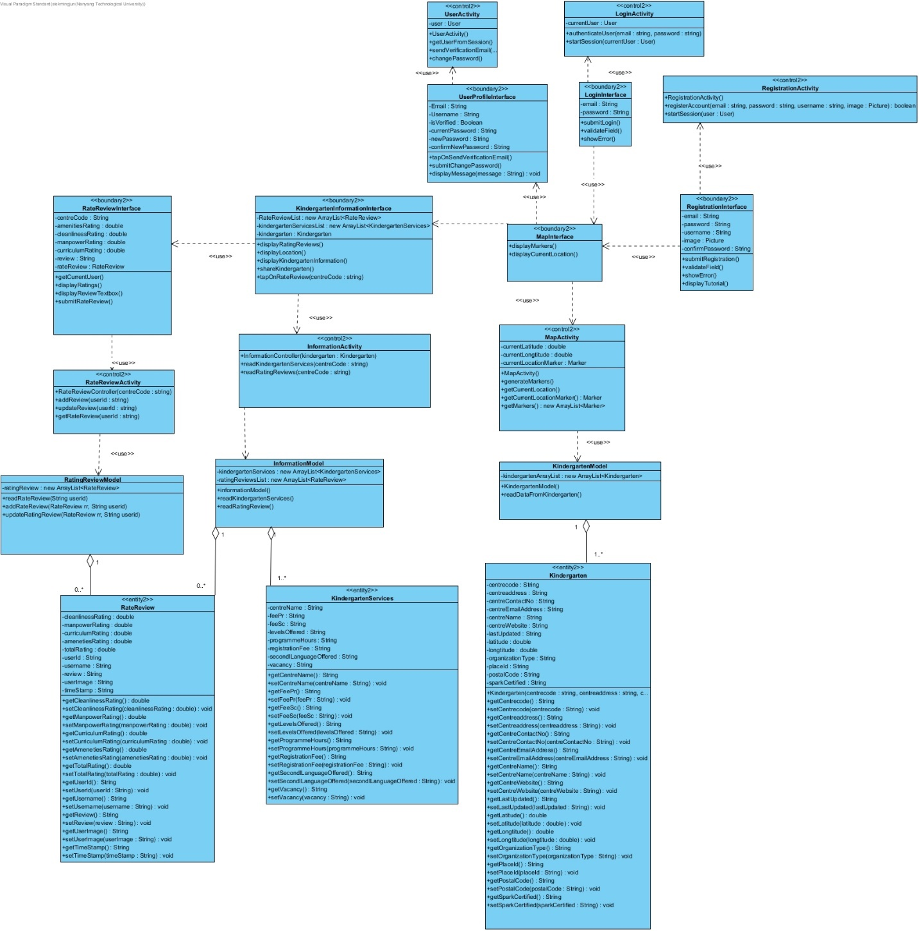

### Sequence Diagram

* + - 1. **Change Password**

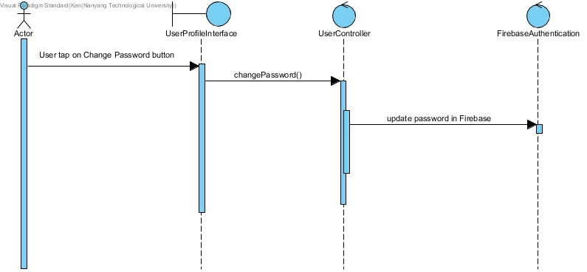

* + - 1. **GenerateMarkersOnMap**

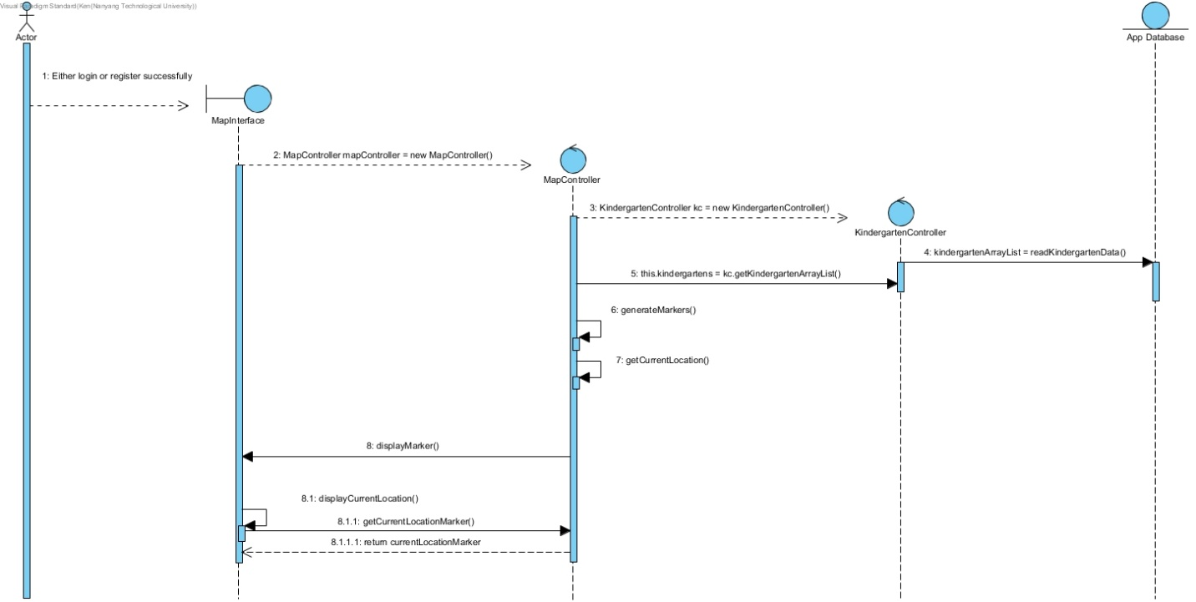

* + - 1. **Login**

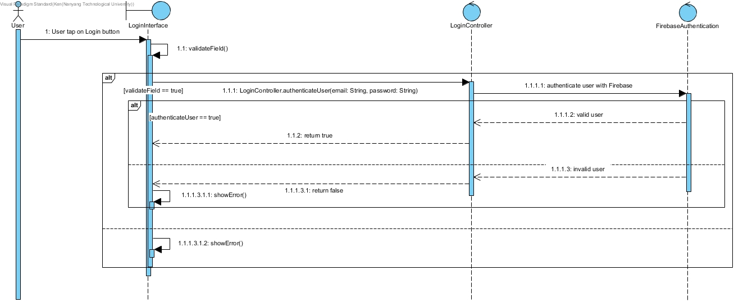

* + - 1. **Register**

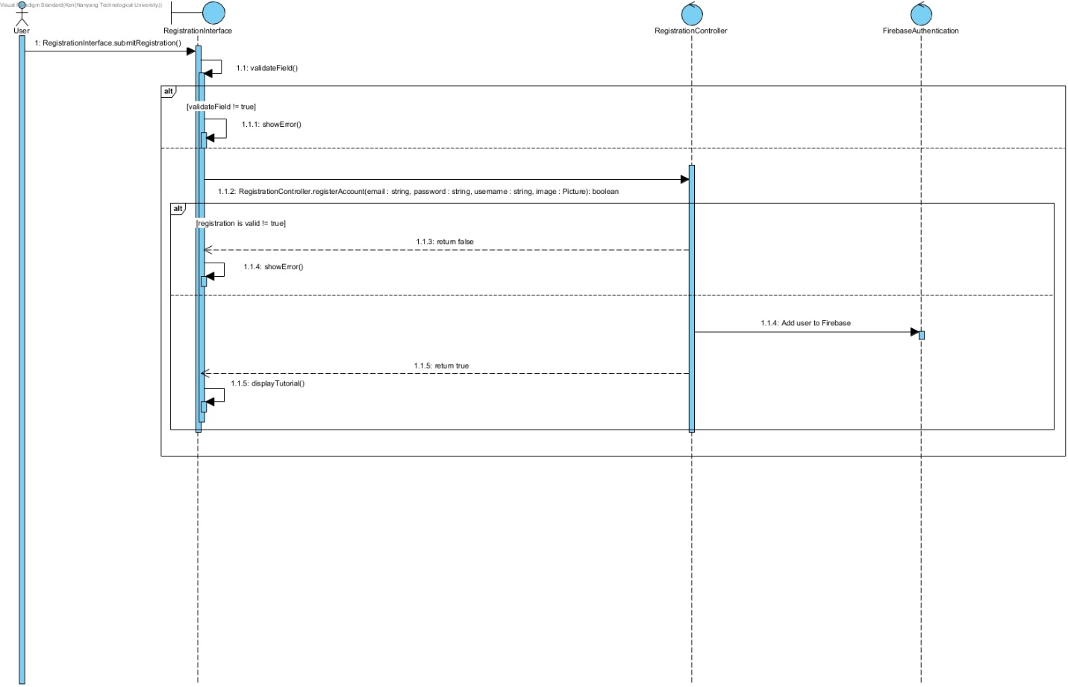

* + - 1. **Search for Specific Kindergarten**

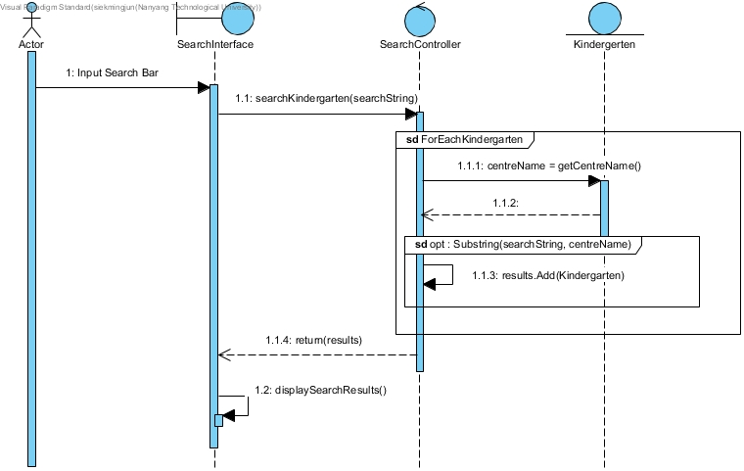

* + - 1. **Send Verification Email**

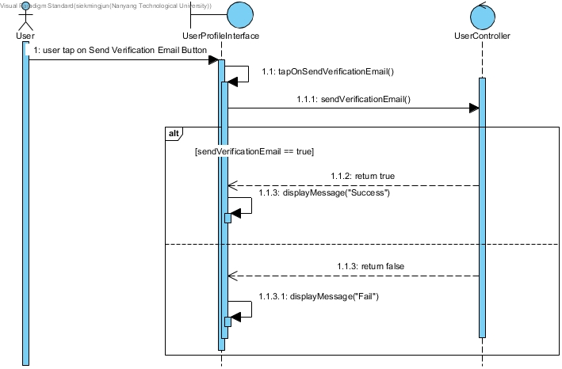

* + - 1. **Share Kindergarten**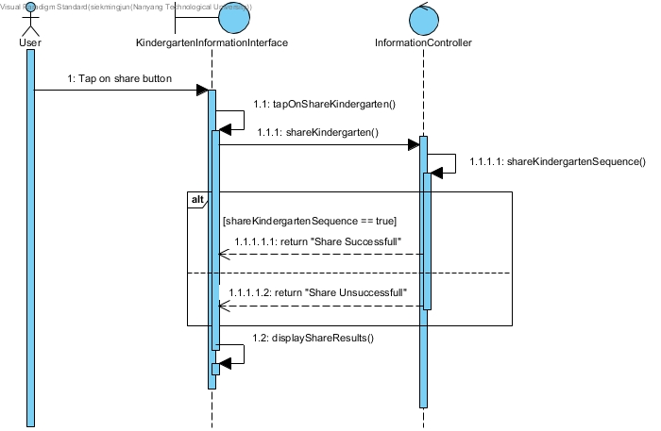
      2. **Submit Ratings and Review**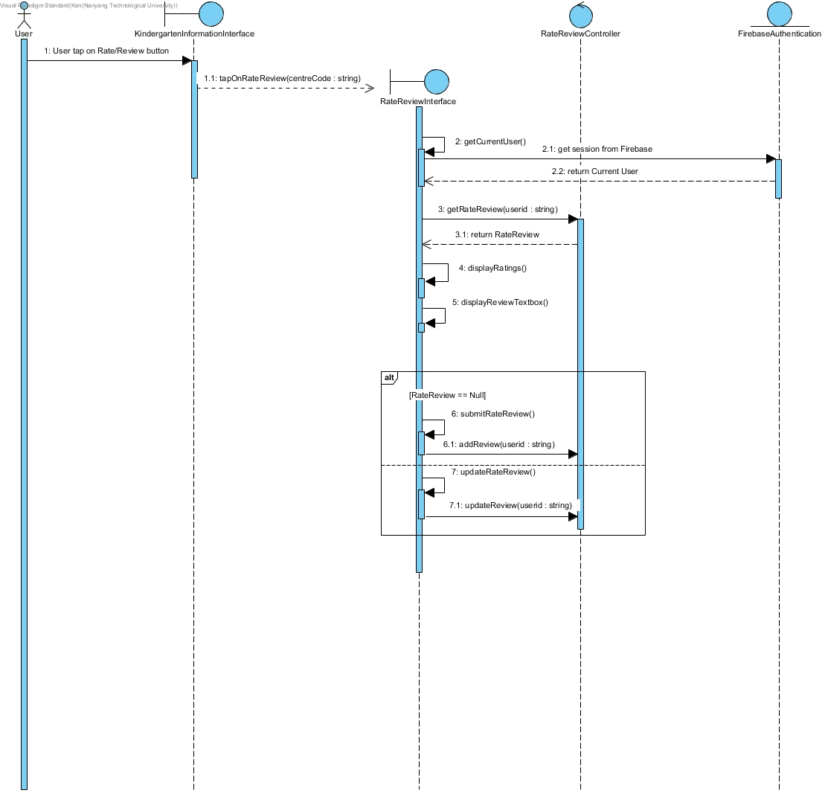
      3. **Tap on Kindergarten**

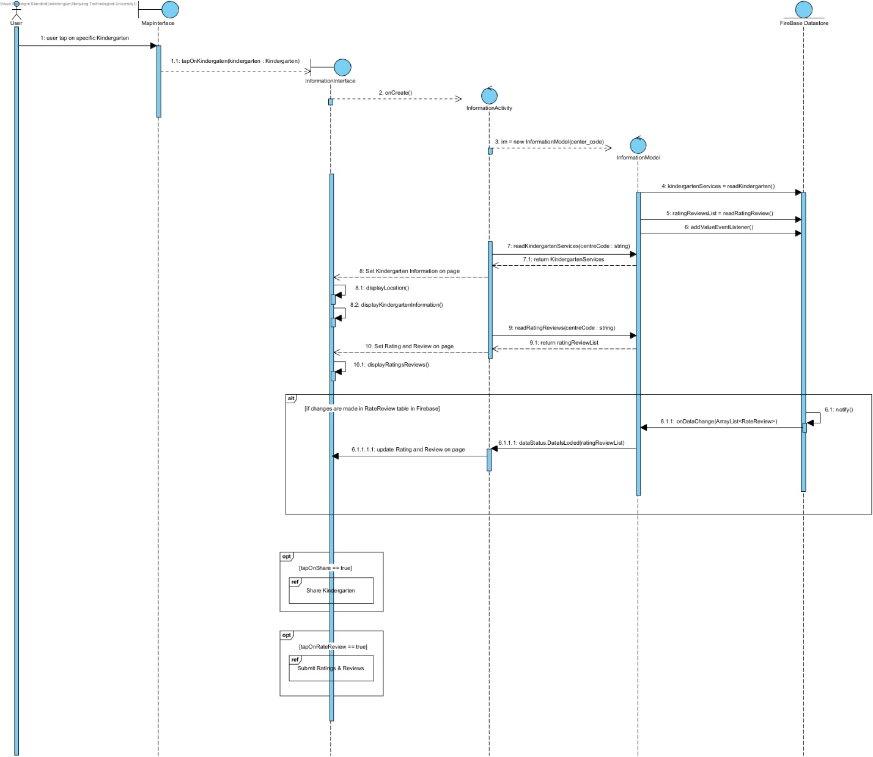

### Dialog Map

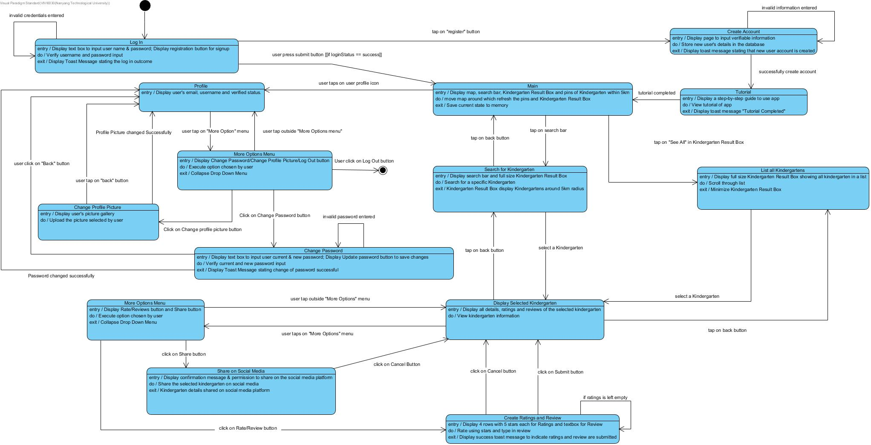

### Prototype UI

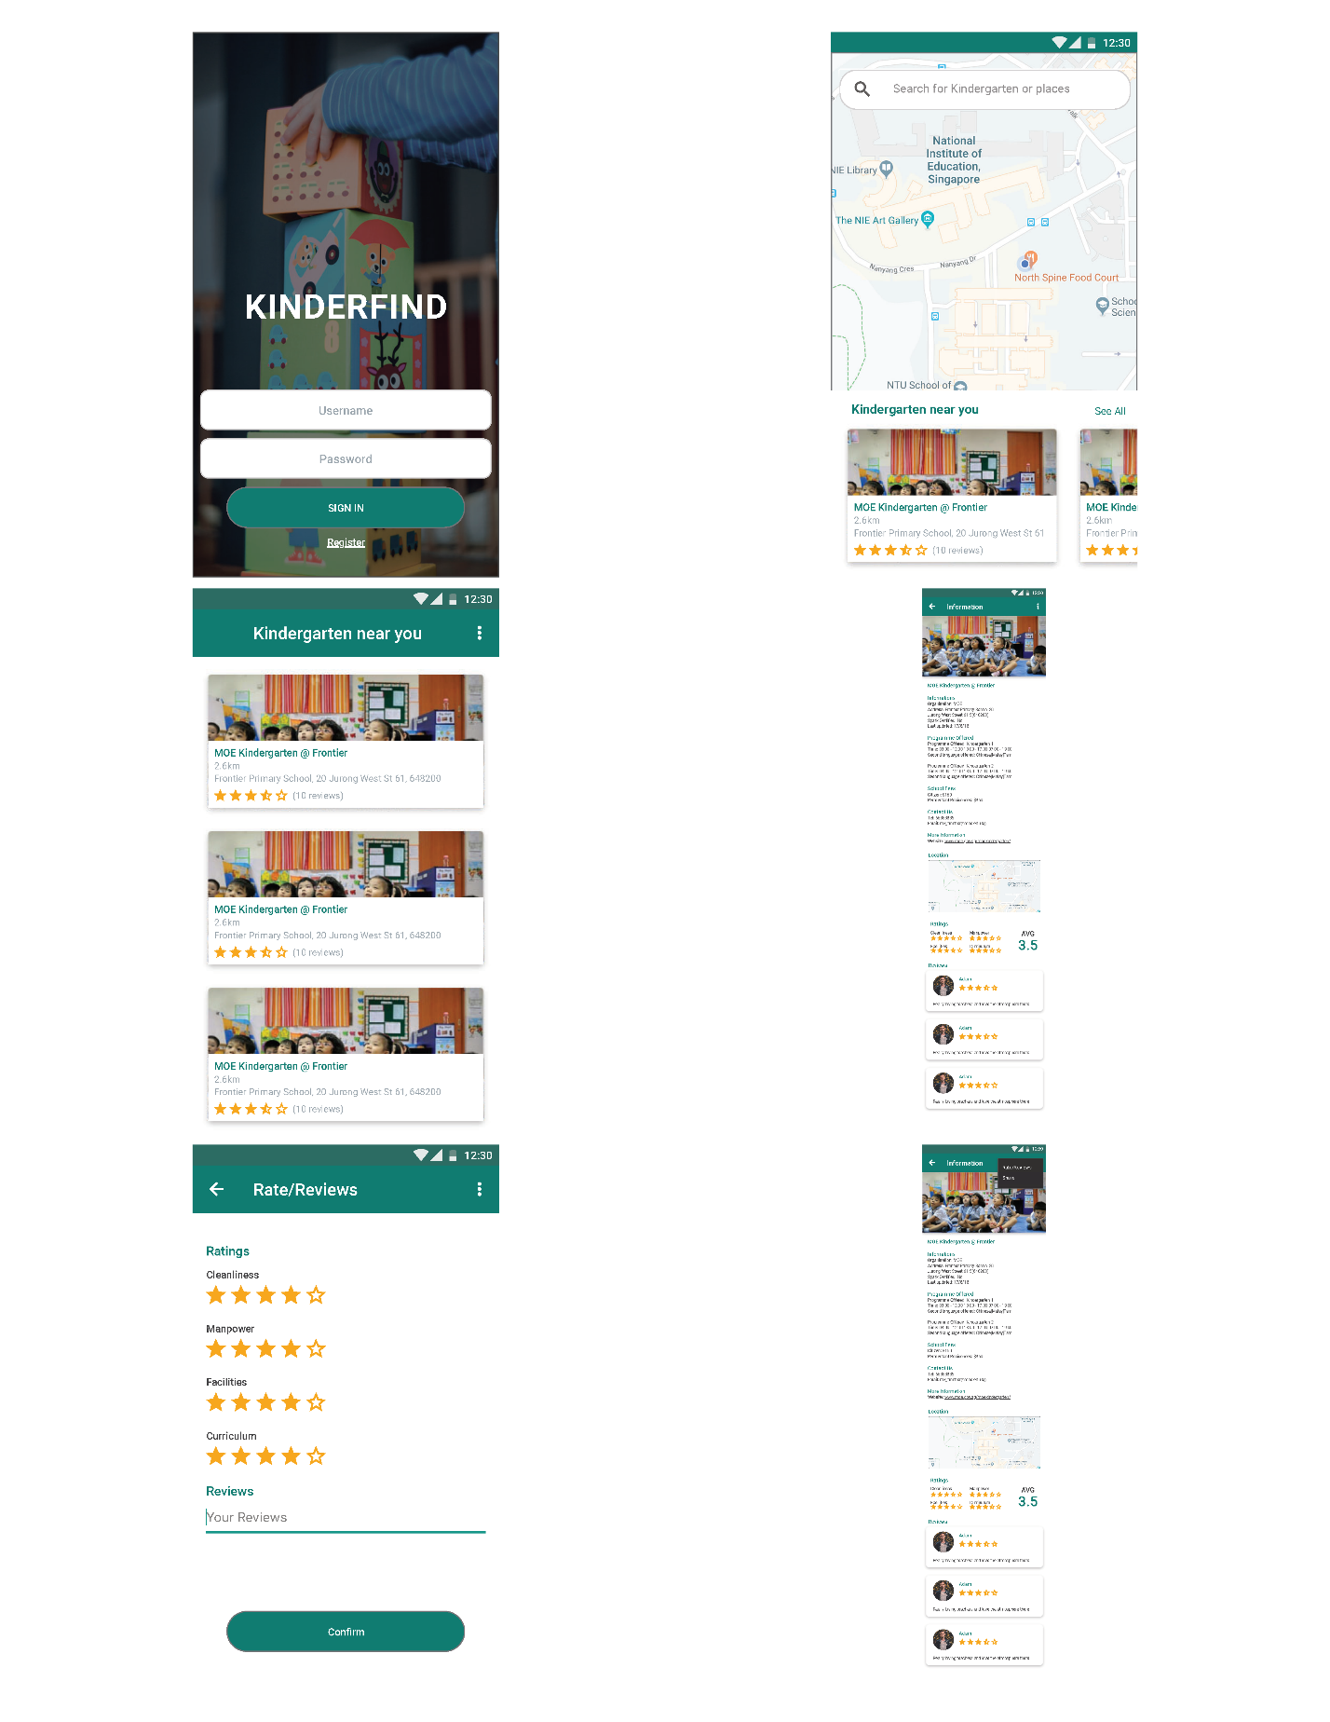

## User Classes and Characteristics

**Parents (Children Enrolled):**

This class of users will be using this app to leave their rating and review for a specific kindergarten. Also, each user can leave only their rating and review once, but they can edit it anytime. Thus, they are not expected to fully utilize the app as they will only be going to their specific choice of kindergarten and leave a rating and review.

**Parents (Children Not Enrolled):**

This class of users will be using this app to do research. We expect these class of users to fully utilize our app the most. This class of users will be doing extensive research on nearby kindergarten in order to make an informed decision on where to send their children to. Thus, the app will allow them to search for a kindergarten of their choice and provide all the relevant information of each kindergarten. Ratings and reviews left on each kindergarten will be very helpful for parents to plan as well. This class of users will most probably not use the Rate/Review function.

**Newly Weds/BTO:**

This class of users will be using this app mostly to do research. They are similar to the Parents (Children Not Enrolled) class but they are more focused to view and search for Kindergarten locations near them. This class of users will most likely use this app in order to decide if the area that they want to live in is convenient for them. This is a factor that they consider because they will want to plan for the future when they have children. Thus, we expect these users to just use the Map function to see how many kindergartens are nearby.

## Operating Environment

Android Studio v3.5:

The app will be developed entirely in Java using Android Studio.

Android 6 and above:

Kinderfind will be operating on Android OS. Android v6.0 and above.

Firebase

The app will have to parse data retrieved from Firebase where all the dataset is contained.

Google Map

The app will utilize Google Map API in order to integrate the Map function in our app.

Social Media

Social Media Applications (e.g. Telegram/WhatsApp/Facebook/Twitter/Instagram) must be installed in the OS to run Social Media sharing functions.

## Design and Implementation Constraints

1. There is a constraint on who can use this app. We developed this app using Android Studio and thus, it is currently only available to Android users only. Apple users will not be able to use this app.
2. There is a constraint on the number of users we can have running this application concurrently. This is because we are using the Spark Plan which is a free plan on Firebase. The constraints are listed below.

Terms used are defined here:

* Authentication is the number of logins allowed.
* Realtime database is where we store our persistent data.
* Storage is where we store user’s profile picture.

Firebase Constraints:

* Authentications -
  + 10,000/month
* Realtime Database -
  + 100 Simultaneous Connections
  + 1 GB Storage
  + 10 GB Downloads/month
* Storage
  + 5GB Storage
  + 1GB Downloads/month
  + 20,000 Upload Operations/day
  + 50,000 Download Operations/day

1. Once the software is delivered to the client, all future maintenance will fall on the client’s organization. Thus, the client’s maintenance team must have prior knowledge and experience with Java, Android Studio, Firebase and Google Map.

## User Documentation

Kinderfind is designed to be a mobile application with high usability to maximize user experience. Thus, it also comes with a tutorial pop-up in the application for first-time users. However, the user must have successfully created an account when registering through the app. They will then be directed to the tutorial page. The tutorial will introduce the main features of the app and allow the user to understand on how to use the app. It will only be displayed once for each unique user. Hence with a tutorial provided, it boosts usability from the first minutes of interaction with the user as it is informative and clear.

## Assumptions and Dependencies

The following assumptions were made to ensure a working system:

1. Firebase will not be down at any point in time.
2. Google Map will not be down at any point in time.
3. Google will not modify the Firebase API such that our system will not be able to have access to Firebase.
4. Users are always connected to the internet.
5. Users will allow location permission.

# External Interface Requirements

## User Interface

All user interface will comply with the guide according to Schneiderman’s Eight Golden Rules.

All user interface will also comply with Google’s Material Design Guidelines.

### Sliding List View - Kindergarten Result Box

A custom sliding list view was implemented in our map page. We call this sliding list view the Kindergarten Result Box. This is used in applications such as Grab and Google Map. We researched and used open source libraries to create this sliding list view in our Map page.

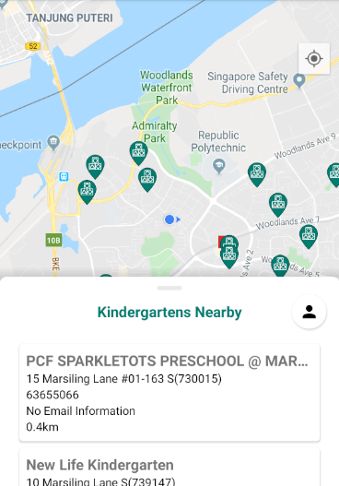

### Action Bar

The action bars in our app stays consistent on all screens following the design shown below. The Search bar replaces the Action bar when the user is on the Map page. This is in accordance to Schneiderman’s Eight Golden Rules, Strive for Consistency.

### 



### Menu Option

The options menu is displayed whenever the action bar appears. Tapping on the options menu will expand the menu displaying options users can tap on. This is in accordance to Schneiderman’s Eight Golden Rules, Reduce Short-term Memory Load.



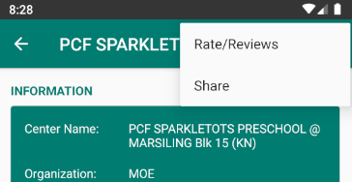

### Buttons

All the buttons in our app follow this design shown below. This is in accordance to Schneiderman’s Eight Golden Rules, Strive for Consistency.



### Informative Toasts

All informative toast in our app follows the design shown below. They will appear at the bottom of the app whenever it is necessary. The message shown will change depending on the context of the situation. This is in accordance to Schneiderman’s Eight Golden Rules, Design Dialog to Yield Closure and Offer Informative Feedback.

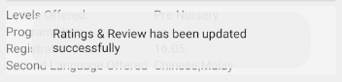

### Card View

Card Views are used as the primary container for most of our app. In the Information page, Card Views are used to contain different information of the Kindergarten. This allows our design to be modular and allow us to add more information to the page if necessary, in the future. This is in accordance to Schneiderman’s Eight Golden Rules, Strive for Consistency.

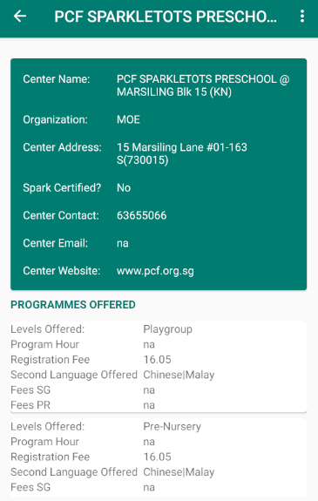

### Ratings Section

The ratings section contains the ratings for Cleanliness, Manpower, Amenities and Curriculum. Each rating has its own Stars ranging from 1 to 5. The average rating shows the total average ratings given by all the users for that kindergarten. This is in accordance to Google’s Material Design Guidelines.

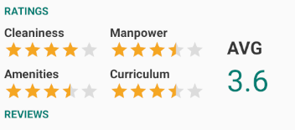

### Reviews Section

The Review Section contains all the reviews users have given for a particular kindergarten. Each review contains user, rating and review information. The review section is sorted by time, showing the latest review at the top. This is in accordance to Google’s Material Design Guidelines.

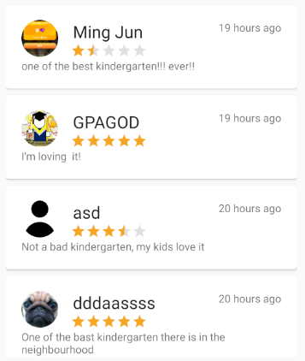

### Confirmation Dialogs

All confirmation dialog follows the design shown below. A confirmation dialog is shown with different messages and titles depending on the context of the situation. This is in accordance to Schneiderman’s Eight Golden Rules, Design Dialog to Yield Closure and Offer Informative Feedback.

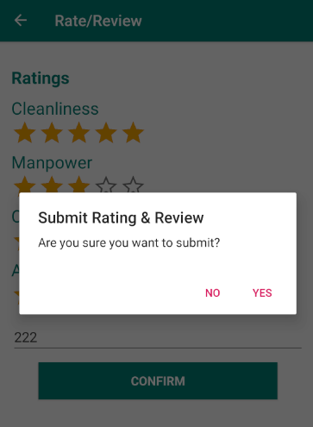

## Adherence to Schneiderman’s 8 Golden Rules

We listed out Ben Schneiderman’s 8 Golden rules below to show the adherence of our app design to those rules.

### Strive for Consistency

Consistent sequences of action should be applied when users are in a similar situation. The app design uses consistent buttons, fonts, action bars and options menu in all the pages of the app. Similar components are also used in the Map page so users will feel familiar when using the app for the first time. This further strengthens the consistency of the app.

### Cater to Universal Usability

The app design is simple and intuitive to use. We included a tutorial when the user successfully registered an account. Thus, there will not be a steep learning curve when a new user starts using the app. This allows most age groups to be able to use the app easily. Since the design we implemented is used in most of the apps out in the world, users will not have an issue adjusting to the design of this app.

### Offer Informative Feedback

Depending on the actions performed by the users, different informative feedback will be displayed to the user. This allows users to be aware of all the changes that was made due to their interaction with the app.

### Design Dialog to Yield Closure

Sequences of actions should be organized into groups with beginning, middle and end. When the user performs actions such as logging in, a loading bar will appear and prevent users from tapping on anything else on the page. This prevents users from performing unwanted actions. When the app is done authenticating the user, a success toast message will appear and bring the user to the Map page. Thus, every action performed by the users will yield closure on the app.

### Permit Easy Reversal of Actions

This feature relieves anxiety on our user as they know an error can be undone. When user creates or edits their ratings and reviews, when they click the submit button, a confirmation pop-up will appear asking them if they want to submit ratings and reviews. If the user realized they made a mistake, they could tap on “No” and go back to the page to fix the mistake. Even if they have already submitted, they are still able to change their ratings and reviews. This will allow the user to be less anxious when performing these actions.

### Support Internal Locus of Control

Experienced operators strongly desire the sense that they are in charge and system responds to their actions. When a user is logged in, they have the freedom to log out at any point in time. They have the freedom to post a rating and review at any point in time. Users are not forced to have a profile picture as they will be provided with a default picture. Thus, all actions that can be performed on the app will be based on how the user interact with the app. The system will respond according to the type of actions they performed.

### Reduce Short-Term Memory Load

Humans information processing in short term memory is limited. We need our app design to be simple and for multiple page displays to be consolidated. Thus, our app design uses a top down information structure where more details will be shown to the users only if they navigate deeper into the app. This prevent the app from displaying too much information and overwhelmed the user.

### Prevent Error

The app is designed such that users cannot make a serious error. If an error is made, an informative toast message will pop up telling them about the error made. Prevention is also done to help reduce the number of errors a user can perform. For example, when a user searches for an invalid kindergarten, the app immediately notifies the user that there is no such kindergarten. App is also programmed to handle network related errors which prevent the app from crashing.

## Software Interfaces

APIs used in the application:

1. data.gov.sg dataset - To retrieve Kindergarten and List of Kindergarten Services Dataset.
2. Google Map API - To integrate Map functionalities in our app.
3. Firebase Authentication - To store, retrieve and update user information.
4. Firebase Real-Time Database - To store, retrieve and update ratings and reviews.
5. Firebase Storage - To store, retrieve and update the user’s profile picture.

## Communications Interfaces

* Communication with the APIs uses HTTPS protocol.
* Android Studio provides libraries with HTTPS native support.

# System Features

## Login

### Description and Priority

The user must already have a registered Kinderfind account. Upon launching the app, the login page will be shown. The user must enter their email as username and password details. If user’s credential is valid, user will be successfully logged in and be redirected to the Map page. Else, authentication will fail, and a toast message will pop up informing user about the error.

Priority: High

### Stimulus/Response Sequences

1. User open Kinderfind app.
2. User brought to login page.

### Functional Requirements

REQ-1: App must provide an error message when incorrect login details are entered.

REQ-1.1: App must display a toast message stating login is successful.

REQ-1.2: App must allow users to log out at any point in time after they log in.

## Registration

### 4.2.1 Description and Priority

For first-time users, upon clicking the “Register” button. The app will direct user to the registration page to input verifiable information to create an account. When creating an account, the user must make sure that the password contains at least 8-16 characters. To ensure the account is created successfully, the user must key in all required information correctly.

Priority: High

### 4.2.2 Stimulus/Response Sequences

1. User tap on Register button at the login page.
2. User brought to Register page.

### 4.2.3 Functional Requirements

REQ-1: App must provide account creation process for first time users using verifiable information.

REQ-1.1: Verifiable information must include email

REQ-1.2: App must provide an error message when incorrect information is entered.

REQ-1.3: Verification email must be sent to the user’s email.

## Tutorial

### 4.3.1 Description and Priority

Kinderfind must provide tutorials only for first-time users. After the account is created, a tutorial pop-up will be displayed. The tutorial will introduce the main features of the app and allow the user to understand how to use the app.

Priority: Medium

### 4.3.2 Stimulus/Response Sequences

1. User successfully register an account.
2. User will be brought to the Tutorial page.

### 4.3.3 Functional Requirements

REQ-1: App must provide tutorial for first time users.

REQ-1.1: Tutorial must be clear and precise in teaching the users.

## View Map

### 4.4.1 Description and Priority

The map page will display all kindergartens location in Singapore using markers. If the user allows location permission, the map will be zoomed in to the user’s current location and display all the markers around the user. The Kindergarten Result Box will show all the nearest kindergarten from the users and be sorted by distance based on the closest kindergarten. If the user denies location permission, the map will be zoomed in to the centre of Singapore and the Kindergarten Result Box will display kindergarten sorted alphabetically. Users will be able to use the search bar at the top of the page to search for kindergarten.

Priority: High

### 4.4.2 Stimulus/Response Sequences

1. After user successfully logged in, they will be brought to the map page.
2. If user allows location permission, map will be zoomed in to user’s current location.
3. Kindergarten Result Box will display kindergarten sorted by the closest kindergarten.
4. Else, map will zoom to the center of Singapore.
5. Kindergarten Result Box will display kindergarten sorted alphabetically.
6. Users tap on marker on map.
7. Kindergarten Result Box is updated to show the kindergarten selected and display relevant information.
8. User taps on a kindergarten in Kindergarten Result Box and is brought to the Information page.

### 4.4.3 Functional Requirements

REQ-1: App must request for permission to access the user’s location.

REQ-1.1: If permission is granted, the app must show nearby kindergarten’s location with a radius of 5km.

REQ-1.1.1: The app must display kindergarten in the 5km radius in ascending order based on the nearest kindergartens in the Kindergarten Result Box.

REQ-1.1.2: Users must be able to tap on each location and view important information

REQ-1.1.2.1: The app must display name of the kindergarten.

REQ-1.1.2.1: The app must display address of the kindergarten.

REQ-1.1.2.1: The app must display contact of the kindergarten.

REQ-1.1.2.1: The app must display email of the kindergarten.

REQ-1.1.2.1: The app must display distance between user and kindergarten.

REQ-1.1.3: The app shall provide more detailed information of a kindergarten by tapping on the specific kindergarten.

REQ-1.2: App must show all kindergartens in Singapore if permission is not granted.

REQ-1.2.1: Kindergartens must be listed in alphabetical order in the Kindergarten Result Box.

## Search Kindergarten

### Description and Priority

The user can search for kindergartens by inputting a search string in the search bar.

Priority: High

### Stimulus/Response Sequences

1. The user taps on the search bar and types in keywords to search for relevant kindergartens.
2. Kindergarten Result Box is updated in real time based on what the user is typing.
3. If search string is invalid, Kindergarten Result Box will notify user that kindergarten is not valid.
4. Else, Kindergarten Result Box will display the kindergarten that has the search string either in the name, address or postal code.

### Functional Requirements

REQ-1: App must allow users to search for a location of a kindergarten using details of the kindergarten.

REQ-1.1: App must allow users to search for a location of a kindergarten using postal code.

REQ-1.2: App must allow users to search for a location of a kindergarten using name of kindergarten.

REQ-1.2.1: App must allow users to search for a location of a kindergarten using part of the name of kindergarten.

REQ-1.3: App must allow users to search for a location of a kindergarten using the address of kindergarten.

REQ-1.3.1: App must allow users to search for a location of a kindergarten using part of the address of kindergarten.

REQ-1.4: An informative message must be displayed if no results are found.

REQ-1.5: Results must be displayed in the Kindergarten Result Box.

## View Kindergarten Details

### Description and Priority

Users can view detailed information on a selected Kindergarten, which includes general information, program information and geographical location of the Kindergarten. The ratings and reviews posted by other users can also be seen on this page

Priority: High

### Stimulus/Response Sequences

1. In the map page, user select a kindergarten in the Kindergarten Result Box.
2. User will be brought to the Information page.

### Functional Requirements

REQ-1: The app shall provide more detailed information of a kindergarten by tapping on the specific kindergarten.

REQ-1.2: App must display opening hours of the kindergarten.

REQ-1.3: App must display classes of the kindergarten.

REQ-1.4: App must display reviews of the kindergarten.

REQ-1.4.1: App must display review in inverse chronological order.

REQ-1.5: App must display ratings of the kindergarten.

REQ-1.5.1: App must display the average rating of the kindergarten.

REQ-1.6: App must display if a kindergarten is spark certified.

REQ-1.7: App must display pricing of the kindergarten.

REQ-1.7.1: App must show pricing for Singapore Citizens

REQ-1.7.2: App must show pricing for Permanent Residents.

## Submit Ratings and Reviews

### Description and Priority

Users will be able to submit review and ratings on a kindergarten. Ratings will be on a scale of 1 - 5 stars and can be conducted on 4 categories, namely Cleanliness, Manpower, Curriculum and Amenities.

Priority: High

### Stimulus/Response Sequences

1. In the information page, user taps on the options menu on the top right corner.
2. User taps on Rate/Review button.

### Functional Requirements

REQ-1: Users must be verified before leaving a rating and review

REQ-1.1: App must allow users to leave a review of a kindergarten.

REQ-1.1.1: Each user shall only leave a review once per kindergarten.

REQ-1.1.2: Users must not be able to submit multiple reviews for a kindergarten.

REQ-1.1.3: Users must be able to amend their review.

REQ-1.2: App must allow users to leave ratings of a kindergarten.

REQ-1.2.1: User must rate the kindergarten based on the categories.

REQ-1.2.1.1: User must rate the kindergarten based on Cleanliness.

REQ-1.2.1.2 User must rate the kindergarten based on Manpower.

REQ-1.2.1.3: User must rate the kindergarten based on Curriculum.

REQ-1.2.1.4: User must rate the kindergarten based on Amenities.

REQ-1.2.2: Each user shall only leave ratings once per kindergarten.

REQ-1.2.3: Users must not be able to submit multiple ratings for a kindergarten.

REQ-1.2.4: Users must be able to amend their ratings.

REQ-1.2.5: Average rating must be the weighted average based on Cleanliness, Manpower, Curriculum and Facility.

## Share Kindergarten

### Description and Priority

The user can share a kindergarten on a selected social media platform

Priority: Medium

### Stimulus/Response Sequences

1. In the information page, user taps on the options menu on the top right corner.
2. User tap on Share button.

### Functional Requirements

REQ-1: Users must be able to share information about a kindergarten on their preferred social media platform through the “share via” menu.

REQ-1.1: App must display list of social media apps currently installed on user’s device.

## View Profile Page

### Description and Priority

The Profile Page displays the user’s account information.

Priority: Medium

### Stimulus/Response Sequences

From the home page, the user presses the Profile Page Icon to access the Profile Page

### Functional Requirements

REQ-1: App must have a profile page to display user’s information.

REQ-1.1: App must display user’s current profile picture.

REQ-1.1.1: App must allow user to change profile picture

REQ-1.2: App must display user’s username.

REQ-1.3: App must display verification status of user.

REQ-1.4: App must display user’s email address.

REQ-1.5: App must allow user to resend verification email in the profile page if they have not verified their email.

REQ-1.6: App must allow user to change password.

REQ-1.7: App must allow user to log out in the profile page.

# Other Nonfunctional Requirements

## Performance Requirements

1. The app must run on Android phones running Android 6.0 and above.
   * Using version below Android 6.0 may allow our app to be susceptible to security flaws in previous Android versions.
2. The app must be developed entirely in Java.
   * Android Studio uses Java as its programming language.
3. The app must be able to fetch kindergarten information within 500ms when user taps on a pin on the map.
   * This is to allow the app to be responsive to changes made by the user.
4. The app must be able to fetch kindergarten information within 500ms when user search for a kindergarten using the search bar.
   * This is to allow the app to be responsive to changes made by the user.
5. On opening the app, the app must be fully functional within 5 seconds.
   * This is to prevent user’s frustration when using the app.
6. If network connection is not available, app must display an informative pop-up box telling the user to try again later.
   * This is to inform users that there is a network error and to ask for their understanding.

## Usability Requirements

1. Users must not spend more than 10 minutes to create an account. This is to prevent user’s frustration when trying to create an account.

## Software Quality Attributes

Kinderfind is built with usability in mind. It offers informative error messages to let its users know what could have went wrong when an error occurs. These include the following.

1. If network connection is not available, app must display an informative pop-up box telling the user to try again later.
2. On creation of accounts, if the password input by the user is not within 8 – 16 characters, an error message informs the user to input a password of length in that range
3. On creation of accounts, Kinderfind informs its users if the email input is invalid.
4. On changing passwords, if the new password input by the user is not within 8 – 16 characters, an error message informs the user to input a password of length in that range

## Business Rules

### User must register before using the app

As our application allows users to rate and review kindergarten, we require users to register an account beforehand. Only when they have successfully created an account, will they be able to access the functionality of the app.

### User must be verified before posting ratings and review

As posting ratings and reviews for a kindergarten is very important, we require users to verify their email address that they used to create the account. This is to ensure that their emails are valid, and they did not register using a fake email.

# Appendix A: Data Dictionary

|  |  |
| --- | --- |
| **Terms** | **Description** |
| Verifiable Information | Information that can be used to validate if the user is a human. |
| Kindergarten Result Box | A side scrolling panel located at the bottom of the app that shows information of kindergartens. |
| App | The android mobile application itself. |
| User | The person who is using the android mobile application. |
| Categories | The various criteria used for ratings for a kindergarten. Categories are Cleanliness, Manpower, Curriculum and Facility. |
| Cleanliness | Refers to the parent’s perception of the overall cleanliness of the kindergarten as well as how the staff takes care of the children’s hygiene. |
| Manpower | Refers to the parent’s perception of the staff in the kindergarten such as teachers and administration officer. |
| Curriculum | Refers to the parent’s perception of the kindergarten’s curriculum |
| Facility | Refers to the parent’s perception of the overall facility of the kindergarten. |
| Rating | A measure of user’s satisfaction based on a category, ranging from 1 to 5 stars. 1 star depicts very unsatisfied while 5 starts depicts very satisfied. |
| Average Rating | The rating of a kindergarten, ranging from 1 to 5 stars based on the weighted average of ratings from the categories. |
| Review | Comments from users that describe their satisfaction or dissatisfaction with the kindergarten. |
| Opening hours | The timings in which the kindergarten is in operation. |
| Spark Certified | A Kindergarten certified by the Ministry of Education that have met the baseline quality standards in areas such as Curriculum, Pedagogy and Health, Hygiene and Safety. |
| Search | Search for a specific kindergarten using the app search bar according to the user’s input. |
| Results | A list of kindergartens that a user has searched for using the search bar. |
| System | Refers to the APIs we use for our app. Mainly Google Map API and Gov Data API. |